**Getting Started with Raspberry Pi:**

Step 1: Install heat sinks and insert Micro SD Card and enclose Raspberry Pi in the case:

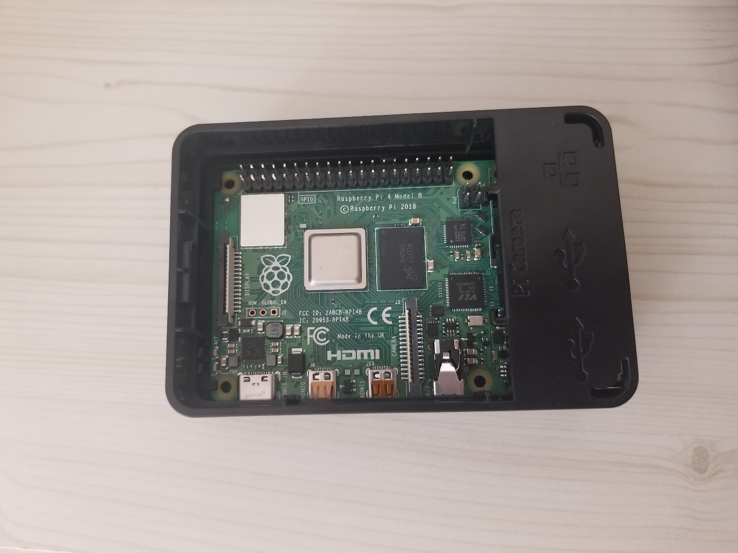

Step 2: Install cooling fan to keep the Pi cool:

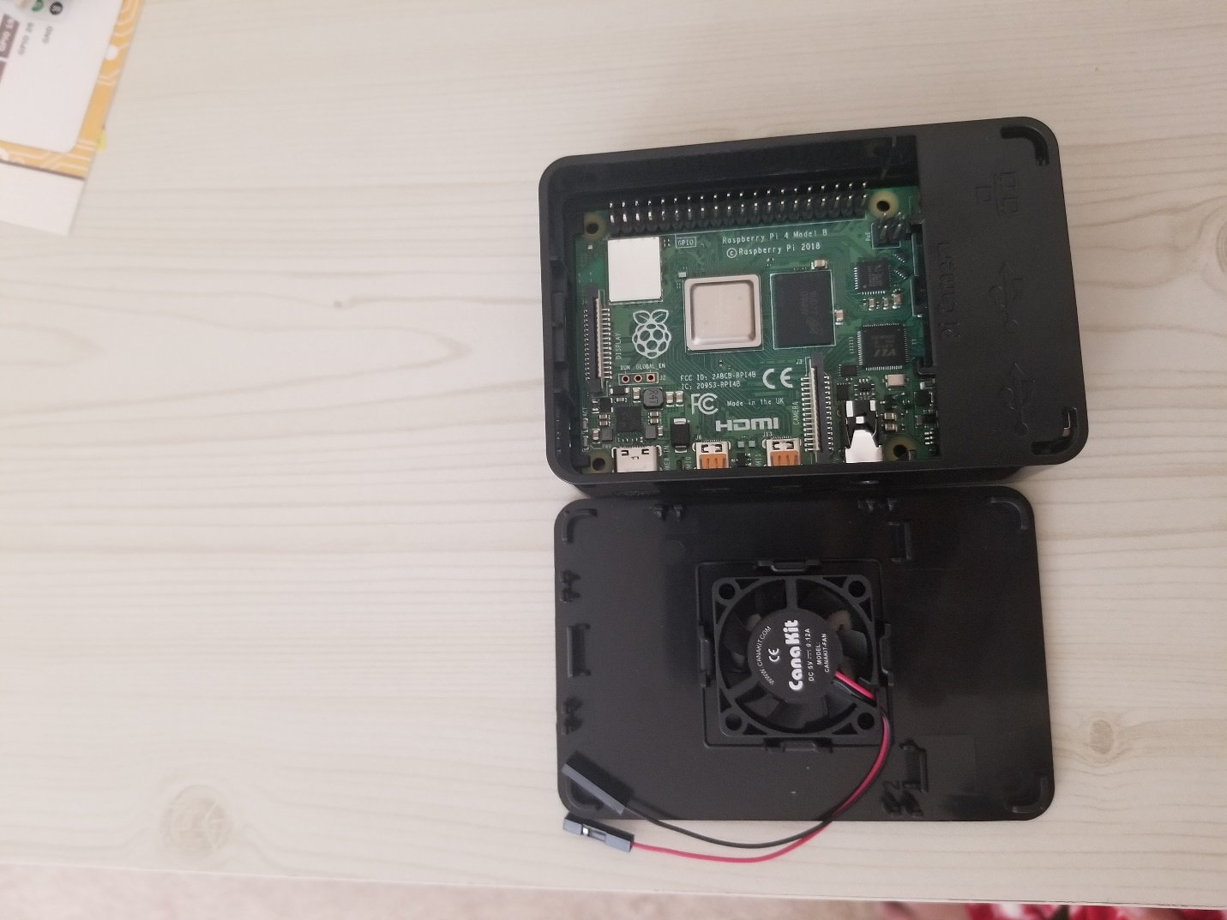

Step 3: Close the case and connect your Pi to a mouse and a monitor and using the power adapter, power it up. The following screen appears:

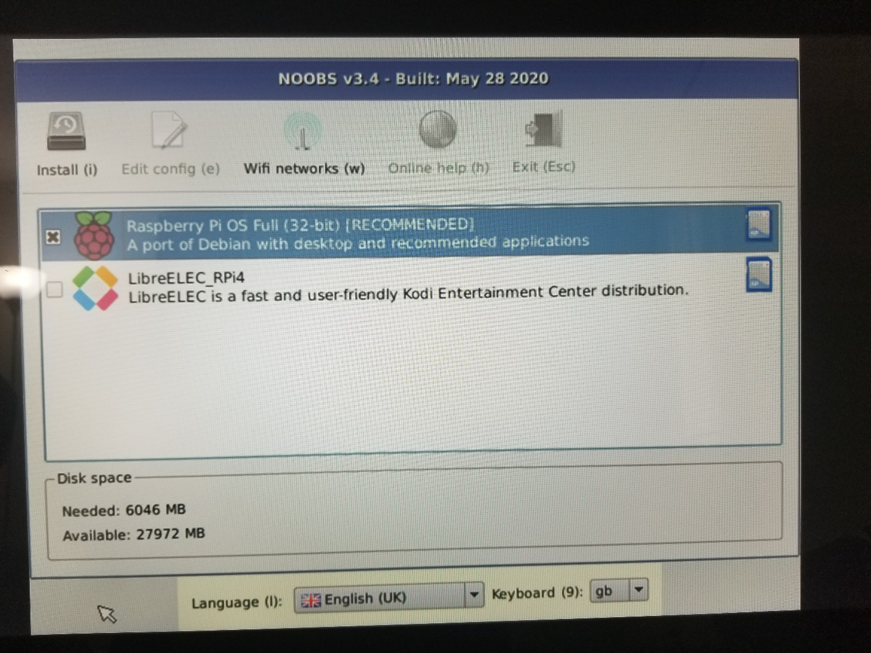

Step 4: Select Raspberry Pi OS and let NOOBS install the OS.

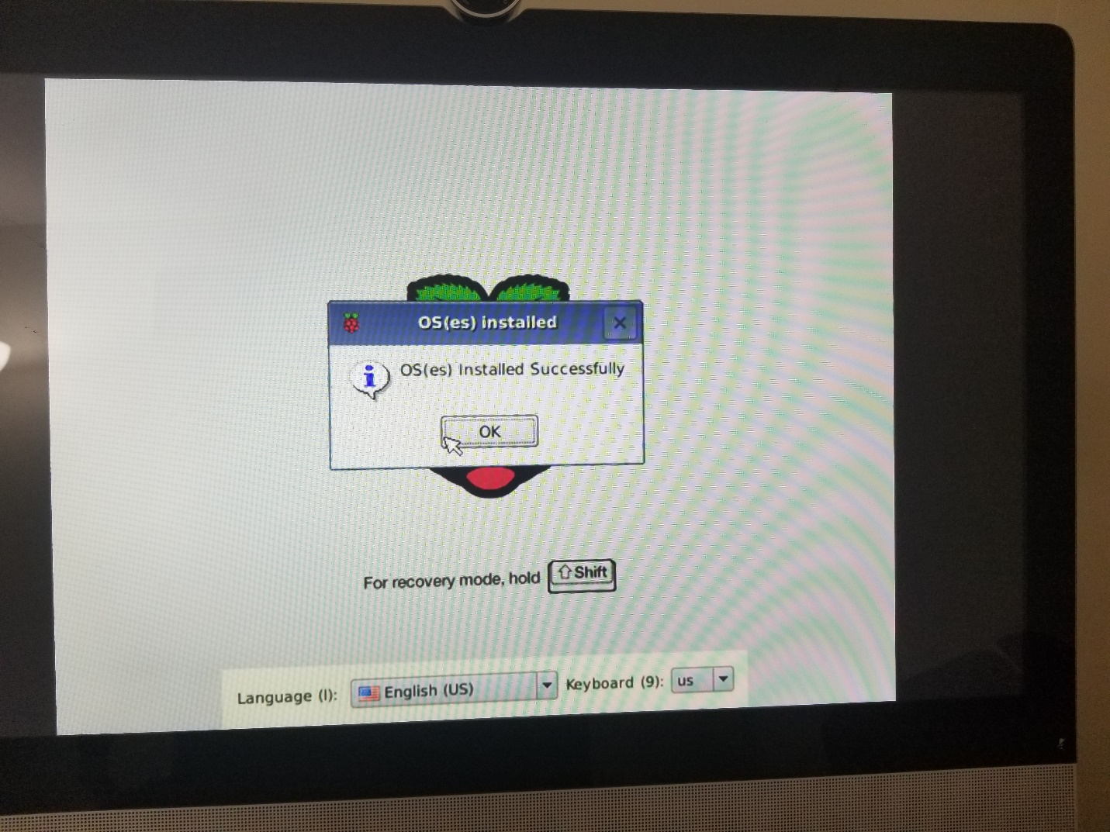

Step 5: Raspbian OS has been installed successfully. Now change the password and reboot the Pi. Once it boots up, connect your Pi to Wi-Fi network.

